## **Prim's Algorithm**

**Prim's algorithm takes a weighted, undirected, connected graph as input and returns an MST of that graph as output**.

**It works in a greedy manner**. In the first step, it selects an arbitrary vertex. Thereafter, **each new step adds the nearest vertex to the tree constructed so far** until there is no disconnected vertex left.

Let's run Prim's algorithm on this graph step-by-step:

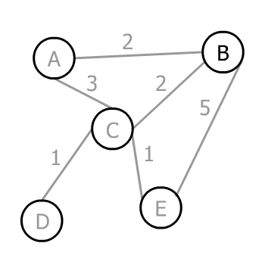

Assuming the arbitrary vertex to start the algorithm is B, we have three choices A, C, and E to go. The corresponding weights of the edges are 2, 2, and 5, therefore the minimum is 2. In this case, we have two edges weighing 2, so we can choose either of them (it doesn't matter which one). Let's choose A:

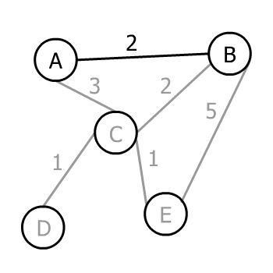

Now we have a tree with two vertices A and B. We can select any of A or B's edges not yet added that lead to an unadded vertex. So, we can pick AC, BC, or BE.

Prim's algorithm chooses the minimum, which is 2, or BC:

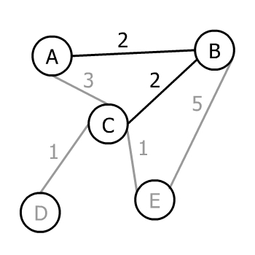

Now we have a tree with three vertices and three possible edges to move forward: CD, CE, or BE. AC isn't included since it wouldn't add a new vertex to the tree. The minimum weight amongst these three is 1.

However, there are two edges both weighing 1. Consequently, Prim's algorithm chooses one of them (again doesn't matter which one) in this step: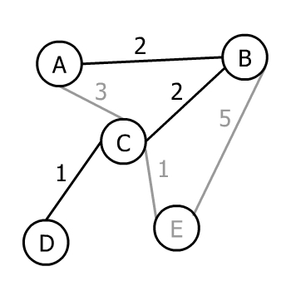

There is only one vertex left to join, so we can pick from CE and BE. The minimum weight that can connect our tree to it is 1, and Prim's algorithm will choose it:

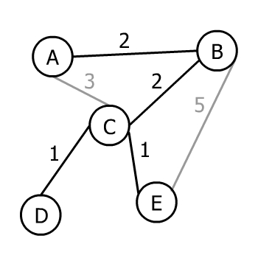

As all vertices of the input graph are now present in the output tree, Prim's algorithm ends. Therefore, this tree is an MST of the input graph.

## **4. Implementation**

Vertices and edges make graphs, so we need a data structure to store these elements. Let's create the class *Edge*:

public class **Edge** {

private **int** weight;

private **boolean** isIncluded = false;

}

Copy

Each *Edge* must have a *weight* since Prim's algorithm works on weighted graphs. *isIncluded* shows whether the *Edge* is present in the minimum spanning tree or not.

Now, let's add the *Vertex* class:

public class **Vertex** {

private **String** label = null;

private Map<Vertex, Edge> edges = new **HashMap**<>();

private **boolean** isVisited = false;

}

Copy

Each *Vertex* can optionally have a *label*. We use the *edges* map to store connections among vertices. Finally, *isVisited* shows whether the vertex has been visited by Prim's algorithm so far or not.

Let's create our *Prim* class where we'll implement the logic:

public class **Prim** {

private List<Vertex> graph;

}

Copy

A list of vertices is enough to store the whole graph because inside each *Vertex*, we have a *Map<Vertex, Edge>* to identify all connections. Inside *Prim,* we create a *run()* method:

public void **run**() {

if (graph.size() > 0) {

graph.get(0).setVisited(true);

}

while (isDisconnected()) {

**Edge** nextMinimum = new **Edge**(Integer.MAX_VALUE);

**Vertex** nextVertex = graph.get(0);

for (Vertex vertex : graph) {

if (vertex.isVisited()) {

Pair<Vertex, Edge> candidate = vertex.nextMinimum();

if (candidate.getValue().getWeight() < nextMinimum.getWeight()) {

nextMinimum = candidate.getValue();

nextVertex = candidate.getKey();

}

}

}

nextMinimum.setIncluded(true);

nextVertex.setVisited(true);

}

}

Copy

We start by setting the first element of the *List<Vertex> graph* as visited. The first element can be any of the vertices depending on the order they've been added to the list in the first place. *isDisconnected()* returns *true* if there is any *Vertex* not visited so far:

private **boolean** **isDisconnected**() {

for (Vertex vertex : graph) {

if (!vertex.isVisited()) {

return true;

}

}

return false;

}

Copy

While the minimum spanning tree *isDisconnected()*, we loop over the already visited vertices and find the *Edge* with the minimum weight as a candidate for *nextVertex:*

public Pair<Vertex, Edge> **nextMinimum**() {

**Edge** nextMinimum = new **Edge**(Integer.MAX_VALUE);

**Vertex** nextVertex = this;

Iterator<Map.Entry<Vertex,Edge>> it = edges.entrySet()

.iterator();

while (it.hasNext()) {

Map.Entry<Vertex,Edge> pair = it.next();

if (!pair.getKey().isVisited()) {

if (!pair.getValue().isIncluded()) {

if (pair.getValue().getWeight() < nextMinimum.getWeight()) {

nextMinimum = pair.getValue();

nextVertex = pair.getKey();

}

}

}

}

return new **Pair**<>(nextVertex, nextMinimum);

}

Copy

We find the minimum of all *candidate*s in the main loop and store it in *nextVertex*. Then, we set *nextVertex* as visited. The loop goes on until all vertices are visited.

At the end, **each *Edge* with *isIncluded* equal to *true* is present.**

Note that since *nextMinimum()* iterates through the edges, the time complexity of this implementation is *O(V2)*. If we store the edges in a priority queue (sorted by weight) instead, the algorithm will perform in *O(E log V)*.

## **5. Testing**

Okay, so now that we've got some code, let's test it with a real example. First, we construct our graph:

public static List<Vertex> **createGraph**() {

List<Vertex> graph = new **ArrayList**<>();

**Vertex** a = new **Vertex**("A");

...

**Vertex** e = new **Vertex**("E");

**Edge** ab = new **Edge**(2);

a.addEdge(b, ab);

b.addEdge(a, ab);

...

**Edge** ce = new **Edge**(1);

c.addEdge(e, ce);

e.addEdge(c, ce);

graph.add(a);

...

graph.add(e);

return graph;

}

The constructor of the *Prim* class takes it and stores it inside the class. We can print the input graph with *originalGraphToString()* method:

**Prim** prim = new **Prim**(createGraph());

System.out.println(prim.originalGraphToString());

Our example will output:

A --- 2 --- B

A --- 3 --- C

B --- 5 --- E

B --- 2 --- C

C --- 1 --- E

C --- 1 --- D

Copy

Now, we run Prim's algorithm and print the resulting MST with *minimumSpanningTreeToString()* method:

prim.run();

prim.resetPrintHistory();

System.out.println(prim.minimumSpanningTreeToString());

Copy

Finally, we print out our MST:

A --- 2 --- B

B --- 2 --- C

C --- 1 --- E

C --- 1 --- D